For loop

Workshop #3

Flutter Developer Bootcamp

# **Purpose**

This workshop demonstrates the use of a for loop to iterate over a range of integers (start to end) and perform a set of operations (in this case, printing each integer).

**Problem**

In the given workshop demonstrates StringInputStream and assigns it to a variable stream, although correct instantiation should use StringInputStream() to create an object. The main() function initializes variables start and end, then uses a for loop to print numbers from 0 to 3 sequentially. This example introduces basic Dart syntax, including variable declaration, class definition, and loop usage, providing foundational understanding for further programming concepts in Dart. You need to print numbers from 0 to 5 sequentially.

**How to Solve**

1. Checkout the workshop from Git Repo:

git clone -b <user-branch> <repo-URL>

1. Open the root folder inside VS Code
2. Open the root folder in terminal
3. Run the command dart run filename.dart
4. Instantiate StringInputStream correctly using StringInputStream() to create an object.
5. Declare stream variable and assign it an instance of StringInputStream().
6. Initialize start variable to 0 and end variable to 5.
7. Utilize a for loop to iterate from start to end, inclusive (0 to 5).
8. Print each value of i during each iteration of the loop using print(i).
9. Go To File: <specific-file--method> à <method-name>, implement your logic.

**You will Achieve**

When you complete this workshop you will learn the following:

**Methods and Functions Used:**

* **main() Function:**
* Entry point of the Dart program where execution begins.
* Initializes variables and controls the flow of the program.
* **Class Instantiation (StringInputStream()):**
* Correctly instantiates the StringInputStream class to create an object instance.
* **Variable Declaration and Initialization:**
* Demonstrates the use of var keyword for variable declaration (var stream, var start, var end).
* **For Loop:**
* Uses a for loop to implement iterative behavior, iterating over a sequence of integers (int i = start; i <= end; i++).
* **Print Function (print(i))**
* Outputs the current value of i to the console during each iteration of the loop.

# **Screenshots**

## **Before implementation (without printing 5 numbers)**

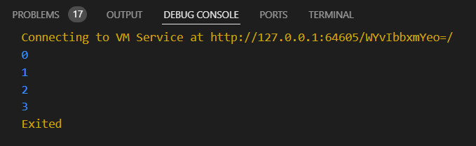

## **After implementation (with printing 5 numbers)**

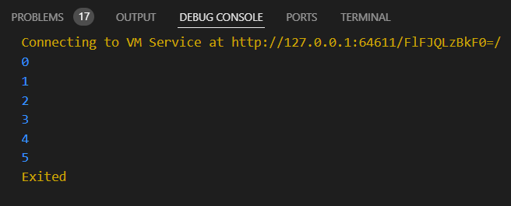

# **How to submit your workshop**

Push your project back to the same git branch using command:

<command name>

# **Happy Coding!**